APPENDICES

Appendix A: Sample questionnaire

Title: Questionnaire on Digital Infrastructure, Student Readiness, and School Type Influence on AI Adoption in Learning (QDISRSTIAAL)
Dear Respondent,
This questionnaire is designed strictly for academic research purposes. Your responses are anonymous and will be treated with complete confidentiality. Please answer all questions honestly by ticking (✓) the option that best represents your opinion. There are no right or wrong answers. Your sincere responses are highly appreciated.
Thank you for your participation.
SECTION A: DEMOGRAPHIC INFORMATION
Please tick (✓) or fill in the appropriate option.
- School Name: ________________________________________
- School Type:
☐ Public
☐ Private
SECTION B: Availability of Digital Infrastructure to Support AI-Based Learning
Instructions: Indicate your level of agreement with the following statements about digital infrastructure in your school that could support AI-based learning (e.g., AI chatbots, adaptive learning apps, online platforms).
Response Scale: 1 = Strongly Disagree, 2 = Disagree, 3 = Neither Agree nor Disagree, 4 = Agree
5 = Strongly Agree
S/N | Statement | 1 | 2 | 3 | 4 | 5
1 | My school has enough computers, laptops, or tablets for students to use AI learning tools. | ☐ | ☐ | ☐ | ☐ | ☐
2 | There is reliable high-speed internet access in my school for using online AI platforms. | ☐ | ☐ | ☐ | ☐ | ☐
3 | Electricity supply in my school is stable enough to support digital/AI activities without interruption. | ☐ | ☐ | ☐ | ☐ | ☐
4 | My school has functional ICT rooms or computer labs with working devices suitable for AI applications. | ☐ | ☐ | ☐ | ☐ | ☐
5 | Technical support (e.g., ICT staff or maintenance personnel) is available when digital devices or internet fail. | ☐ | ☐ | ☐ | ☐ | ☐
6 | My school provides access to necessary software/apps (e.g., browsers, AI chat tools, learning platforms) for AI-based learning. | ☐ | ☐ | ☐ | ☐ | ☐
7 | The internet speed and stability in my school are sufficient for downloading/uploading AI-generated content or videos. | ☐ | ☐ | ☐ | ☐ | ☐
8 | Overall, the digital infrastructure in my school is adequate to enable effective use of AI tools for learning. | ☐ | ☐ | ☐ | ☐ | ☐

SECTION C: Student Readiness to Adopt AI Technologies in Learning
Instructions: Indicate your level of agreement with the following statements about your preparedness and attitude toward using AI technologies (e.g., ChatGPT, AI tutors, and adaptive learning apps).
S/N | Statement | 1 | 2 | 3 | 4 | 5
9 | I have good digital skills (e.g., using computers, browsing the internet, using apps). | ☐ | ☐ | ☐ | ☐ | ☐
10 | I understand basic concepts of AI (e.g., what chatbots do, how AI personalizes learning). | ☐ | ☐ | ☐ | ☐ | ☐
11 | I feel confident using AI tools (e.g., asking AI for explanations or summaries) for my schoolwork. | ☐ | ☐ | ☐ | ☐ | ☐
12 | I am motivated to learn how to use AI tools to improve my exam preparation and understanding. | ☐ | ☐ | ☐ | ☐ | ☐
13 | Using AI tools seems easy and straightforward for me. | ☐ | ☐ | ☐ | ☐ | ☐
14 | I believe AI tools would help me understand difficult subjects faster. | ☐ | ☐ | ☐ | ☐ | ☐
15 | I am open to trying AI technologies in my learning despite limited prior experience. | ☐ | ☐ | ☐ | ☐ | ☐
16 | Overall, I am ready and prepared to adopt AI technologies to support my learning as an SS3 student. | ☐ | ☐ | ☐ | ☐ | ☐
SECTION D: Adoption of AI Technologies in Learning
Instructions: Indicate your level of agreement with the following statements about your actual or intended use of AI technologies in learning.
S/N | Statement | 1 | 2 | 3 | 4 | 5
17 | I currently use AI tools (e.g., ChatGPT, Google Bard, AI apps) for school assignments or exam preparation. | ☐ | ☐ | ☐ | ☐ | ☐
18 | Using AI tools improves my learning efficiency and academic performance. | ☐ | ☐ | ☐ | ☐ | ☐
19 | I intend to continue or start using AI tools regularly in my studies. | ☐ | ☐ | ☐ | ☐ | ☐
20 | AI tools provide personalized help that traditional methods do not offer. | ☐ | ☐ | ☐ | ☐ | ☐
21 | I frequently use AI for research, summarizing notes, or generating study questions. | ☐ | ☐ | ☐ | ☐ | ☐
22 | Overall, I have adopted (or plan to adopt) AI technologies meaningfully in my learning process. | ☐ | ☐ | ☐ | ☐ | ☐
END OF QUESTIONNAIRE
Thank you for completing this questionnaire. Your responses are valuable for improving AI integration in secondary education in Omoku.

Appendix B: Reliability analysis of study variables using Cronbach’s Alpha
SCALE | NUMBER OF ITEMS | CRONBACH’S ALPHA | INTERPRETATION (GEORGE & MALLERY, 2020)
Digital Infrastructure (Section B) | 8 | 0.945 | Excellent
Student Readiness (Section C) | 8 | 0.964 | Excellent
AI Adoption (Section D) | 6 | 0.927 | Excellent
OVERALL INSTRUMENT | 22 | 0.837 | GOOD

Appendix C: Population data of public secondary schools in Omoku

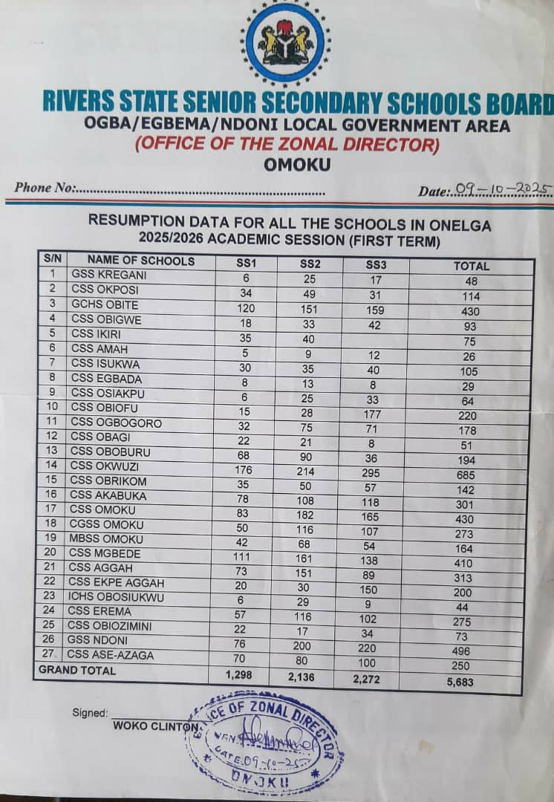
Appendix D: Population data of SS3 students – Gifted Chosen Model School (private school).

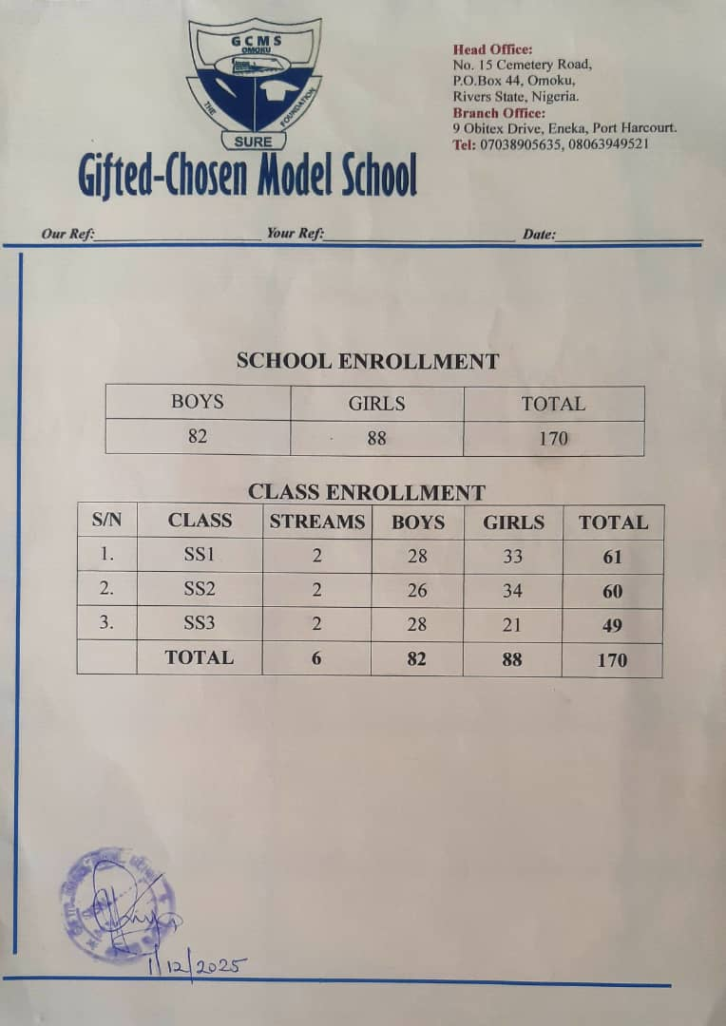

Appendix E: Population data of SS3 students – Becky Academy (private school)

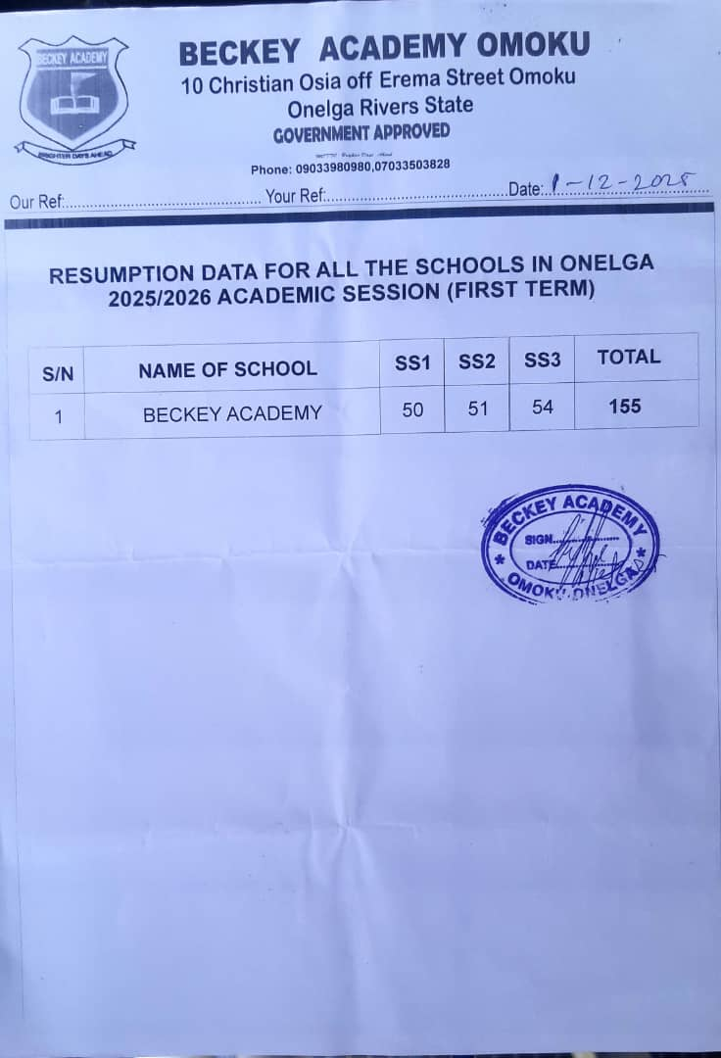
APPENDIX F: Distribution of SS3 student population, allocated sample size, questionnaires administered, retrieved, and response rates by school
S/N | School Name | SCHOOL TYPE | POPULATION OF SS3 STUDENTS (h) | PROPORTION OF TOTAL POPULATION (%) =  $\frac{h}{N}$× 100 | ALLOCATED SAMPLE SIZE  nh = $n\frac{Nh}{N}$ | NUMBER OF QUESTIONNAIRES ADMINISTERED (Qa) | QUANTITY OF QUESTIONNAIRES RETRIEVED AND OK (Qr) | PERCENTAGE RETRIEVED (%)  (%) = $\frac{Qr}{Qa}×100$
1. | Becky Academy | Private | 54 | 5.33 | 15 | 15 | 13 | 86.7
2. | Bolym Wisdom Academy | Private | 30 | 2.96 | 8 | 8 | 7 | 87.5
3. | Ellah International School | Private | 29 | 2.86 | 8 | 8 | 7 | 87.5
4. | Fantastic International Academy | Private | 30 | 2.96 | 8 | 8 | 7 | 87.5
5. | Gifted Chosen Model School | Private | 49 | 4.84 | 14 | 14 | 12 | 85.7
6. | Goshen Comprehensive College | Private | 35 | 3.46 | 10 | 10 | 9 | 90.0
7. | Hallmark Academy | Private | 45 | 4.44 | 13 | 13 | 11 | 84.6
8. | Immaculate Comprehensive College | Private | 55 | 5.43 | 15 | 15 | 13 | 86.5
9. | Provil School | Private | 40 | 3.95 | 11 | 11 | 10 | 90.9
10. | Seat of Greatness International | Private | 32 | 3.16 | 9 | 9 | 8 | 88.9
11. | Sunshine Academy | Private | 30 | 2.96 | 8 | 8 | 7 | 87.5
12. | Kings Comprehensive Group Of Schools | Private | 52 | 5.13 | 15 | 15 | 13 | 86.7
13. | Ogba Comprehensive Group of Schools | Private | 58 | 5.73 | 16 | 16 | 14 | 87.5
14. | Cambridge Paradise School | Private | 45 | 4.44 | 13 | 13 | 11 | 84.6
15. | 3rd Tier Academy | Private | 33 | 3.26 | 9 | 9 | 8 | 88.9
16. | Saint Mary Catholic School | Private | 42 | 4.15 | 12 | 12 | 10 | 83.3
17. | Beautiful Cannanland | Private | 28 | 2.76 | 8 | 8 | 7 | 87.5
18. | Model Boys Secondary School | Public | 54 | 5.33 | 15 | 15 | 12 | 80.0
29. | Community Girls Secondary School | Public | 107 | 10.56 | 30 | 30 | 24 | 80.0
20. | Community Secondary School | Public | 165 | 16.29 | 47 | 47 | 37 | 78.7
Total |  |  | 1013 | 100 | 287 | 287 | 240 | 83.6

Source: Field survey, 2025

APPENDIX G: Frequency and percentage breakdown of responses (SA–A–N–D–SD) and mean scores for Sections B–D per school

S/N | SCHOOL | QS | SA | SA% | A | A  % | N | N  % | D | D  % | SD | SD  % | TOTAL | MEAN
1. | Becky Academy | B | 126 | 29.17 | 145 | 33.56 | 120 | 27.78 | 38 | 8.80 | 3 | 0.69 | 432 | 3.82
 |  | C | 59 | 13.66 | 137 | 31.71 | 161 | 37.273 | 67 | 15.51 | 8 | 1.85 | 432 | 3.40
 |  | D | 43 | 13.27 | 118 | 37.42 | 108 | 33.33 | 49 | 15.12 | 6 | 1.85 | 324 | 4.44
2. | Bolym Wisdom Academy | B | 53 | 22.08 | 92 | 38.33 | 70 | 21.17 | 23 | 9.58 | 2 | 0.83 | 240 | 3.71
 |  | C | 43 | 17.92 | 96 | 40.00 | 73 | 30.42 | 26 | 10.83 | 2 | 0.83 | 240 | 3.63
 |  | D | 37 | 20.56 | 74 | 41.11 | 51 | 28.33 | 17 | 9.44 | 1 | 0.56 | 180 | 3.72
3. | Ellah International School | B | 59 | 25.43 | 87 | 37.50 | 64 | 27.59 | 20 | 8.62 | 2 | 0.86 | 232 | 3.78
 |  | C | 38 | 16.38 | 87 | 37.50 | 72 | 31.03 | 32 | 13.79 | 3 | 1.29 | 232 | 3.54
 |  | D | 34 | 19.54 | 55 | 31.61 | 61 | 35.06 | 23 | 13.22 | 1 | 0.57 | 174 | 3.56
4. | Fantastic International Academy | B | 62 | 25.83 | 96 | 40.00 | 64 | 26.67 | 16 | 6.67 | 2 | 0.83 | 240 | 3.83
 |  | C | 38 | 15.83 | 83 | 34.58 | 85 | 35.42 | 32 | 13.33 | 2 | 0.83 | 240 | 3.51
 |  | D | 33 | 18.33 | 64 | 35.56 | 58 | 32.22 | 22 | 12.22 | 3 | 1.67 | 180 | 3.57
5. | Gifted Chosen Model School | B | 111 | 28.32 | 143 | 36.48 | 104 | 26.53 | 29 | 7.40 | 5 | 1.28 | 392 | 3.83
 |  | C | 53 | 13.52 | 135 | 34.44 | 136 | 34.69 | 59 | 15.05 | 9 | 2.30 | 392 | 3.42
 |  | D | 51 | 17.35 | 85 | 28.91 | 112 | 38.10 | 39 | 13.27 | 7 | 2.38 | 294 | 3.46
6. | Goshen Comprehensive College | B | 80 | 28.57 | 99 | 35.36 | 78 | 27.86 | 22 | 7.86 | 1 | 0.36 | 280 | 3.84
 |  | C | 46 | 16.43 | 82 | 29.29 | 116 | 41.43 | 30 | 10.71 | 6 | 2.14 | 280 | 3.47
 |  | D | 45 | 21.43 | 79 | 37.62 | 60 | 28.57 | 23 | 10.95 | 3 | 1.43 | 210 | 3.67
7. | Hallmark Academy | B | 76 | 21.11 | 134 | 37.22 | 115 | 31.94 | 30 | 8.33 | 5 | 1.39 | 360 | 3.68
 |  | C | 66 | 18.33 | 136 | 37.78 | 113 | 31.39 | 38 | 10.56 | 7 | 1.94 | 360 | 3.60
 |  | D | 41 | 15.19 | 81 | 30.00 | 87 | 32.22 | 52 | 19.26 | 9 | 3.33 | 270 | 3.34
8. | Immaculate Comprehensive College | B | 103 | 23.41 | 149 | 33.86 | 135 | 30.68 | 48 | 10.91 | 5 | 1.14 | 440 | 3.68
 |  | C | 44 | 10.00 | 142 | 32.27 | 152 | 34.55 | 84 | 19.09 | 18 | 4.09 | 440 | 3.25
 |  | D | 57 | 17.27 | 95 | 28.79 | 115 | 34.85 | 49 | 14.85 | 14 | 4.24 | 330 | 3.40
9. | Provil School | B | 103 | 32.19 | 121 | 37.81 | 75 | 23.44 | 19 | 5.94 | 2 | 0.62 | 320 | 3.95
 |  | C | 47 | 14.69 | 104 | 32.50 | 120 | 37.50 | 42 | 13.12 | 7 | 2.19 | 320 | 3.44
 |  | D | 38 | 15.83 | 84 | 35.00 | 84 | 35.00 | 27 | 11.25 | 7 | 2.92 | 240 | 3.50
10. | Seat of Greatness International | B | 52 | 20.31 | 88 | 34.38 | 81 | 31.64 | 30 | 11.72 | 5 | 1.95 | 256 | 3.59
 |  | C | 44 | 17.19 | 83 | 32.42 | 85 | 33.20 | 37 | 14.45 | 7 | 2.73 | 256 | 3.47
 |  | D | 35 | 18.23 | 69 | 35.94 | 56 | 29.17 | 30 | 15.62 | 2 | 1.04 | 192 | 3.55
11. | Sunshine Academy | B | 52 | 21.67 | 84 | 35.00 | 77 | 32.08 | 25 | 10.42 | 2 | 0.83 | 240 | 3.66
 |  | C | 52 | 21.67 | 76 | 31.67 | 75 | 31.25 | 34 | 14.17 | 3 | 1.25 | 240 | 3.58
 |  | D | 23 | 12.78 | 69 | 38.33 | 67 | 37.22 | 19 | 10.56 | 2 | 1.11 | 180 | 3.51
12. | Kings Comprehensive Group of Schools | B | 86 | 20.67 | 161 | 38.70 | 127 | 30.53 | 38 | 9.13 | 4 | 0.96 | 416 | 3.69
 |  | C | 61 | 14.66 | 151 | 36.30 | 144 | 34.62 | 49 | 11.78 | 11 | 2.64 | 416 | 3.49
 |  | D | 65 | 20.83 | 107 | 34.29 | 102 | 32.69 | 35 | 11.22 | 3 | 0.96 | 312 | 3.63
13. | Ogba Comprehensive Group Of Schools | B | 81 | 17.46 | 180 | 38.79 | 150 | 32.33 | 46 | 9.91 | 7 | 1.51 | 464 | 3.61
 |  | C | 59 | 12.72 | 144 | 31.03 | 174 | 37.50 | 72 | 15.52 | 15 | 3.23 | 464 | 3.34
 |  | D | 60 | 17.24 | 106 | 30.46 | 116 | 33.33 | 54 | 15.52 | 12 | 3.45 | 348 | 3.43
14. | Cambridge Paradise School | B | 66 | 18.33 | 148 | 41.11 | 100 | 27.78 | 39 | 10.83 | 7 | 1.94 | 360 | 3.63
 |  | C | 40 | 11.11 | 105 | 29.17 | 147 | 40.83 | 56 | 15.56 | 12 | 3.33 | 360 | 3.29
 |  | D | 55 | 20.37 | 111 | 41.11 | 73 | 27.04 | 29 | 10.74 | 2 | 0.74 | 270 | 3.70
15. | 3rd Tier Academy | B | 85 | 32.20 | 89 | 33.71 | 67 | 25.38 | 21 | 7.95 | 2 | 0.76 | 264 | 3.89
 |  | C | 29 | 10.98 | 81 | 30.68 | 103 | 39.02 | 42 | 15.91 | 9 | 3.41 | 264 | 3.30
 |  | D | 46 | 23.23 | 73 | 36.87 | 57 | 28.79 | 20 | 10.10 | 2 | 1.01 | 198 | 3.71
16. | Saint Mary Catholic School | B | 98 | 29.17 | 124 | 36.90 | 87 | 25.89 | 22 | 6.55 | 5 | 1.49 | 336 | 3.86
 |  | C | 56 | 16.67 | 132 | 39.29 | 97 | 28.87 | 45 | 13.39 | 6 | 1.79 | 336 | 3.56
 |  | D | 61 | 24.21 | 83 | 32.94 | 84 | 33.33 | 23 | 9.13 | 1 | 0.40 | 252 | 3.71
17. | Beautiful Cannan Land | B | 69 | 30.80 | 86 | 38.39 | 54 | 24.11 | 14 | 6.25 | 1 | 0.45 | 224 | 3.93
 |  | C | 48 | 21.43 | 93 | 41.52 | 63 | 28.12 | 19 | 8.48 | 1 | 0.45 | 224 | 3.75
 |  | D | 16 | 9.52 | 60 | 35.71 | 52 | 30.95 | 34 | 20.24 | 6 | 3.57 | 168 | 3.27
18. | Model Boys Secondary | B | 5 | 1.16 | 38 | 8.80 | 135 | 31.25 | 155 | 35.88 | 99 | 22.92 | 432 | 2.29
 |  | C | 42 | 9.72 | 139 | 32.18 | 158 | 36.57 | 79 | 18.29 | 14 | 3.24 | 432 | 3.27
 |  | D | 33 | 10.19 | 84 | 25.93 | 126 | 38.89 | 67 | 20.68 | 14 | 4.32 | 324 | 3.17
19. | Community Girls Secondary School | B | 11 | 1.29 | 83 | 9.70 | 268 | 31.31 | 316 | 36.92 | 178 | 20.79 | 856 | 2.34
 |  | C | 105 | 12.27 | 268 | 31.31 | 296 | 34.58 | 151 | 17.64 | 36 | 4.21 | 856 | 3.30
 |  | D | 37 | 5.76 | 154 | 23.99 | 262 | 40.81 | 150 | 23.36 | 39 | 6.07 | 642 | 3.00
20. | Community Secondary School | B | 22 | 1.67 | 136 | 10.30 | 402 | 30.45 | 493 | 37.35 | 267 | 20.23 | 1320 | 2.36
 |  | C | 143 | 10.83 | 379 | 28.71 | 490 | 37.12 | 242 | 18.33 | 66 | 5.00 | 1320 | 3.22
 |  | D | 84 | 8.48 | 270 | 27.27 | 372 | 37.58 | 223 | 22.53 | 41 | 4.14 | 990 | 3.13

Source: Field survey, 2025

