**Impact of** **Technology-Education-Art (TEA) AI application on attitude of higher institution students in biological drawing**

Benjamin Onuorah, Peter Okebukola, Adekunle Oladejo, Michael Ahove & Sanni Rasheed

Africa Centre of Excellence for Innovative and Transformative STEM Education (ACEITSE),

Lagos State University

**ABSTRACT**

**ABSTRACT**

Drawing and visual literacy skill are essential to the success of not just visual art students but also science students and biology students in specific, because biology is the most visually intensive among the science subjects. However studies have shown that students are having challenges with visual literacy skill in biology in Nigeria. This study looks at the effectiveness of the Technology-Education-Art (TEA) application to mitigate these problems. The study used a mixed quantitative and qualitative approach for data gathering. The sample comprised 85 students from two higher institutions in Lagos states. The intact classes of these institutions were used as experimental and control groups. Two instruments - Questionnaire on Student’s Attitudes to Biological Drawing (QSABD) and Students’ Perception about TEA Interview Guide (SPTCIG) - were used to collect quantitative and qualitative data. The QSABD instrument had a reliability value of 0.87. The experimental group were exposed to the TEA application while the control group students learn with the traditional lecture method. The quantitative data gathered were analysed using descriptive and inferential statistics, Research question was analysed using analysis of covariance. The results showed that there is no statistically significant were attained for the attitude of students towards biological drawing. Output of the qualitative data however showed that the students perceived TEA as viable tool for learning biological drawing. Based on the findings of this study and within its limitations, it was recommended that visual literacy skill for science students should be given more attention and relevant authorities should adopt technology for personalized learning experience and AI should not be seen as a treat to learning but as an important tool to support teachers.

**Keywords:** Educational technology, artificial intelligence, biological drawing, visual literacy.

**INTRODUCTION**

Biological drawing is the use of technical illustration to visually communicate the structure and specific details of biological subjects of study. This can be used to demonstrate anatomy, explain biological functions or interactions, direct surgical procedures, distinguish species, and exposing what is unseen in the natural world through external representation using drawings ("Biological illustration", 2022).

A visually literate individual is both a critical consumer of visual media and a competent contributor to a body of shared knowledge and culture. Studies also revealed that students have difficulty in drawing and visual literacy in biology and other science subjects. In a study by Afolasade and Olufunke (2018) which examine the level of visual literacy of students in biology and the effect of visual literacy on biology learning, the result from the study shows that majority of the respondents have low level of visual literacy with 86.7% of the respondents scoring below 50% on Visual Literacy Scale. The authors also noted that biology is considered to be the most visual of the sciences and has a long history of the use of imagery for defining and linking concepts in living systems .

From the outcome of United Nations Educational Scientific and Cultural Organisation (UNISCO) Beijing Consensus on Artificial Intelligence and Education (2019) one of the conclusions of the international body is that Artificial Intelligence (AI) has the potential to address some of the biggest challenges in education today, innovate teaching and learning practices, and accelerate progress towards Sustainable Development Goal (SDG).

However the major challenge with global technology is that Africa is always the least continent to catch up with such technological advancement if at all she did, it is on this basis that this study aim at using web and artificial intelligent technology in solving the identified problem.

## RESEARCH DESIGN

Research design that was used for the study is a 2x2 factorial with method of teaching at two levels (TEA and lecture method) and gender at two levels (male and female). The study was an explanatory sequential design that involved a mixed method of quantitative and qualitative approach to data gathering. Both approaches were used in to provide a comprehensive analysis of the problem and add a greater depth of focus. The quantitative approach was a pretest-posttestst quasi-experimental design to examine the impact of TEA and Lecture method on students’ attitude to biological drawing. The qualitative approach of the study was based on narratives from the students.

## Variables of the study

The following independent, moderator and dependent variables will be considered for this study.

Table 1: Variables of the study

|  |  |  |
| --- | --- | --- |
| **Independent Variables** | **Moderator Variables** | **Dependent Variables** |
| Method of instruction  (TEA Vs Lecture) | Gender (male, female) | Attitude to biological drawing |

## Population and Sample

The population for the study comprised all year three biology education students in Lagos state. With estimated number of 80,000 spread across six higher institutions. Purposive sampling technique was used to select the sample, as they were drawn from the intact classes of two public higher institutions on the basis of convenience and no particular interest within the population from Lagos state. A total of 85 biology education students in the two intact classes of the selected schools participated in this study. The classes were assigned to experimental (TEA) group and control (lecture method) group respectively. Students in the TEA group was 54 (male 12, female 42) and the lecture group had 31 students (male = 7, female = 24).

## Research Instruments

The following instruments was developed and used for data collection:

a. Questionnaire on Student’s Attitudes to Biological Drawing (QSABD)

b. Students’ Perception about TEA and Biological Drawing Interview Guide (SPTBDIG)

## Questionnaire on Student’s Attitudes to Biological Drawing (QSABD)

**Development**

The questionnaire instrument was developed by the researcher to collect data on students attitude toward biological drawing. The instrument was developed to have two sections - Section A sought demographic data of the students, while Section B contained 22 items on a four-point rating scale of strongly agree, agree, disagree and strongly disagree. The items were equally positively and negatively worded.

**Validation and** **Reliability**

The research instrument was subjected to face and content validity by respectable science education researchers from the Lagos State University, they looked at the adequacy of the items in line with the research questions as well as the rating scale. To ascertain the reliability of the instrument, the instruments was administered to 104 students in the pilot group via Google form, and the data was downloaded and analysed using IBM-SPSS and a Cronbach alpha reliability of 0.87 was obtained for the instrument.

* 1. **Students’ Perception about TEA and** **Biological Drawing Interview Guide (****SPTBDIG)**

**Development:** This instrument was designed to obtain in-depth information about students’ perception on the use of TEA  and Biological Drawing. The instrument was developed to have two sections - Section A sought demographic data of the students, while Section B contained three open-ended questions to obtain the desired response on their perception about the use of AI in grading biological drawings.

**Trustworthiness:** Unlike the quantitative data that determines the validity and reliability of the instrument, the qualitative data ensures trustworthiness of a qualitative instrument. The trustworthiness of the SPTBDIG was determined by credibility to ensure accurate findings. This was achieved by a rich, thick description to clarify the objectives of the instrument during the development and also the inclusion of negative or discrepant information. The last step to ensure the credibility of the instrument was collaborating with external peers that have similar knowledge of the study.

## **Procedure for** **data collection**

Letters of introduction from the university authority was obtained and presented to the head of departments (HOD) of the sampled higher institutions for permission to carry out the research in their institutions. After seeking clearance from relevant authorities, the objectives of the study were explained to the HOD and Lecturer in-charge of the course. Next in the line of data collection was the administration of pre achievement and pre attitude test. The following were the order of activities carried out in each week of the study:

* In the first week, the selected institutions involved in the study were visited to seek their consent and approval. This was followed by the explanation the objectives of the study to HODs and Lecturers in-charge of the course.
* Two weeks was used for the administration of the pretest to the two institutions. (Administration of QSABD)
* The treatment (TEA and Lecture) was implemented in four weeks.
* Two weeks was for the administration of posttest (QSABD) and conducting of interview.

## Administration of the Technology-Education-Art (TEA)

TEA is web and artificial intelligence application that the researcher developed to help improve the performance of students’ in biological drawings and visual literacy skill.

**TEA has three functions** **which are:**

1. TEA Awareness and Motivation Portal (TAMP)

2. TEA Drawing Videos Portal (TDVP)

3. TEA Artificial intelligence Evaluation Portal (TAIEP)

## 1. TEA Awareness and Motivation Portal (TAMP)

TAMP provide students with text and video lesson on the importance of biological drawing, rules and guides that can help them to improve in their biological drawings and visual literacy skill.

**2. TEA Drawing Videos Portal (****TDVP)**

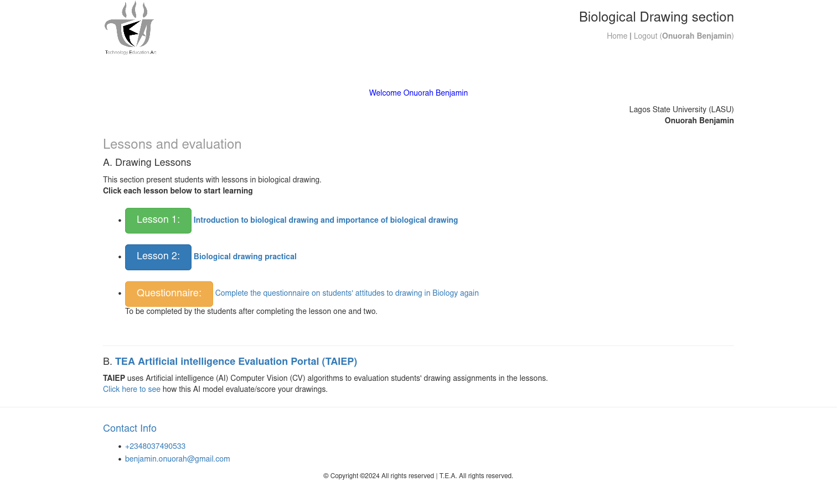  
Figure 1: TEA Biological drawing portal

This section of the application engages the students with practical biological drawing task with a video guide.

## 3. TEA Artificial intelligence Evaluation Portal (TAIEP)

TAIEP is an artificial intelligence (AI) program developed by the researcher that uses computer vision (CV) algorithms to evaluation students' drawings.

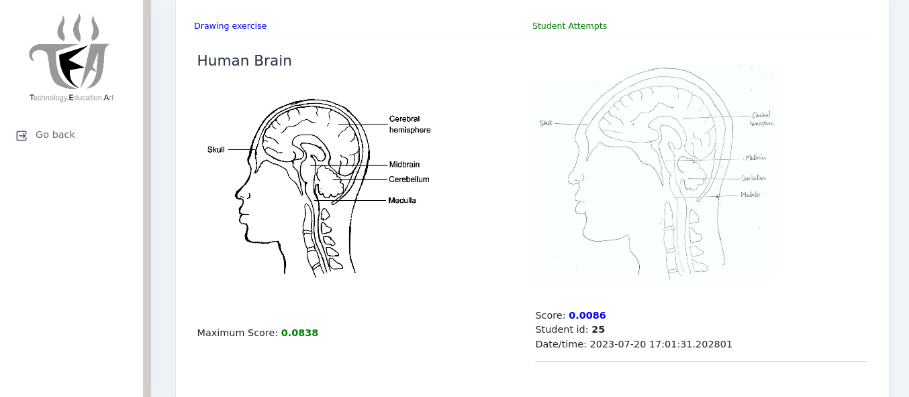

Figure 2: TAIEP Grading

**Technology use for** **TAIEP**

TAIEP uses HTML, CSS and Bootstrap for its front-end while a different technology or programming language was use for the back-end which is python programming language, this is because python programming language is best suited for artificial intelligence and machine learning programming. Flask web framework with Jinja template engine which are both Python tools are used to serve the web interface to provide a user friendly interface with open-source computer vision (OpenCV) library used for computer vision implementation.

**Hu Moments c****omputer vision algorithm**

The computer vision algorithm use for this study is the Hu Moments for shape matching. TAIEPuses this algorithm to compare the drawing exercise with the student drawing and calculate the differences.

***Image Moments***

According to Satya and Krutika (2018) image moments are a weighted average of image pixel intensities. For example, a single channel binary image **I**. The pixel intensity at location **(x,y)** is given by **I(x,y)**.

## **Procedure for Data Analysis**

This study employed a mixed-methods approach. Thus, the quantitative data was analysed using IBM-SPSS, while the qualitative data would be analyses thematically.

Analysis of Covariance (ANCOVA) was the suitable analysis tool used to analyse the quantitative data to answer the research question because the study make use of intact classroom; that is, randomisation of the subjects was not achieved.

## Ethical Consideration

Prior to the collection of data, approval was soughed from the leadership of the ACEITSE of the Lagos State University. Appropriate letters was obtained from the Centre to the various institutions where the study was conducted and permission was granted by the authorities of the sampled institutions before the study began. All participating institutions were properly informed of the purpose of the study without withholding any form of information. To ensure that the study appeared ethical, measures were put in place to ensure that respondents were assured that any information they provided was treated with much caution and confidentiality. Hence, data gathered was exclusively used for academic purposes.

# RESULTS

## Research Question: Is there a statistically significant difference in the attitude of students taught biological drawing using the TEA and lecture method?

**Null Hypothesis****:** There will be no statistically significant difference in the attitude of students taught biological drawing using the TEA and lecture method.

**Procedure:** Descriptive statistics were applied on the pre-test attitude and post-test attitude of the biology groups (TEA and Lecture). Thus, analysis of covariance (ANCOVA) was applied to the attitude with the post-test attitude as dependent variable, pre-test attitude as covariates and method set as fixed factor. The univariate Fs were computed.

Table 2: Summary table of the mean effects of method on the attitude scores of students taught biological drawing

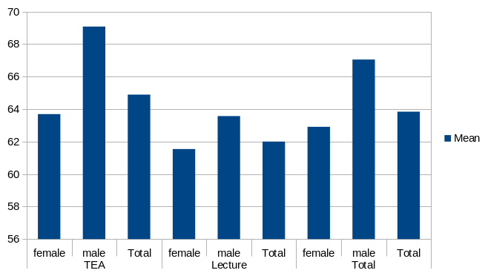Figure 3: Mean effects of method on the attitude of male and female students in biological drawing

|  |  |  |  |  |
| --- | --- | --- | --- | --- |
| **Method** | **Gender** | **Mean** | **Std. Deviation** | **N** |
| **TEA** | female | 63.69 | 10.12 | 42 |
| male | 69.08 | 6.53 | 12 |
| **Total** | **64.89** | **9.66** | **54** |
| **Lecture** | female | 61.54 | 7.90 | 24 |
| male | 63.57 | 11.56 | 7 |
| **Total** | **62.00** | **8.68** | **31** |
| **Total** | female | 62.91 | 9.37 | 66 |
| male | 67.05 | 8.83 | 19 |
| Total | 63.84 | 9.36 | 85 |

Table 3: Levene's Test of Equality of Error Variances

|  |  |  |  |
| --- | --- | --- | --- |
| **F** | **df1** | **df2** | **Sig.** |
| 1.75 | 3 | 81 | .163 |

Table 4: Analysis of Covariance of method on the attitude of students in biological drawing

|  |  |  |  |  |  |  |
| --- | --- | --- | --- | --- | --- | --- |
| **Source** | **df** | **Mean Square** | **F** | **Sig.** | **Partial Eta Squared** | **Decision** |
| Corrected Model | 4 | 257.83 | 3.26 | .02 | .14 |  |
| Intercept | 1 | 5247.14 | 66.27 | .00 | .45 |  |
| Pretest Attitude | 1 | 573.19 | 7.24 | .01 | .08 |  |
| method | 1 | 152.88 | 1.93 | .17 | .02 | *Not rejected* |
| Gender | 1 | 247.99 | 3.13 | .08 | .04 |  |
| method * Gender | 1 | 77.52 | .98 | .33 | .01 |  |
| Error | 80 | 79.18 |  |  |  |  |
| Total | 85 |  |  |  |  |  |
| Corrected Total | 84 |  |  |  |  |  |

**Result and decision on null hypotheses**

After the treatment was implemented to the groups, the mean scores on the post attitude measure were (TEA=64.89; Lecture=62.00). Hence, the TEA group performed better than the Lecture group on account of their mean. The univariate ANCOVA on attitude towards biological drawing shows that there is no statistically significant difference in attitude of students taught biological drawing using the two methods with an F value of 1.93 with an associated p value that is greater than .05. [F(1,80)=1.93; p=.17] with small estimate effect size of .02. Therefore the null hypotheses was not rejected

**Qualitative Findings**

An in-depth interview was also conducted with selected students in the experimental groups to get their responses on the attitude of students to drawing in biology. Some of their responses were presented unedited.

Table 5: Reports of students’ responses from the interview on Attitude of students to biological drawing, TEA App in teaching and grading drawing (unedited)

|  |  |  |
| --- | --- | --- |
| **Pseudo Name** | **Gender** | **Students’ responses (unedited)** |
| Akinrinde Grace Mojisola | Female | *Yes because drawing helps to visualize things and makes learning easier.*  *Answer*  *1. Yes*  *2. Yes because as a biology student, you should be able to know the location and structure of some things in the biological field like organs and drawing helps to visualize that and it also aids in learning* |
| Aishat | Female | *Performance of TEA AI app in grading drawing is still manageable* |
| Disu | Male | Drawing is necessary so as to make our explanation understandable and to identify some key features in biology |
| Keji | Female | Drawing skill is necessary for students to excel in biology |
| Kehinde | Male | My thoughts on biological drawing is that:  Biological drawing is a system of representing visual ideas and thoughts,it is also the use of technical illustration to visually communicate the structure and specific details of biological subject of study.  Basic rules and guidelines in biological drawing.  1.the diagram must have a caption of what we call title.  2.Broken or dotted lines are not allowed unless in cross section.  3.the lines should not be thick.  4.the diagram must be labelled horizontally.  5.the labelling should be straight,and not cancelling each other.  6.lastly,the diagram must have a magnification. |

## CONCLUSION

Based on the findings of this study and within its limitations, it was recommended that visual literacy skill for science students should be given more attention and relevant authorities should adopt technology for personalized learning experience and AI should not be seen as a threat to learning but as an important tool to support teachers.

**Conflict of interest:** On behalf of all authors, the corresponding author states that there is no conflict of interest.

# REFERENCES

|  |
| --- |
| Afolasade, S. A., & Nyong, O. E. (2018). Can They See What It Means: Visual Literacy and Biology Learning in Lagos State Secondary Schools. Jurnal Psikologi Malaysia, 32(2). |
| African Union (2023). Agenda 2063: The Africa We Want. https://au.int/en/agenda2063/overview |
| Ahmed, M. A., & Odewumi, M. O. (2020). Impact of Visual Learning Devices on Secondary School Biology Students’ Academic Performance in Ilorin, Nigeria. Indonesian Journal of Science and Education, 4(2), 83-98 |
| Ajose, R. T. (2021). The effects of culturo-techno-contextual approach (CTCA) in improving the achievement of secondary school students in energy flow in the ecosystem Unpublished undergraduate project, Lagos State University). |
| Biological illustration. (2022, July 28) In Wikimedia. https://en.wikipedia.org/wiki/Biological_illustration |
| Satya M. and Krutika B. (2018). Shape Matching using Hu Moments (C++/Python). LearnOpenCV. https://learnopencv.com/shape-matching-using-hu-moments-c-python/ |
| UNESCO (2019). International Conference on Artificial Intelligence and Education, Planning Education in the AI Era. Beijing Consensus on Artificial Intelligence and Education. https://www.unesco.org/en/education/digital/artificial-intelligence |